In the same population of 60 year old men with µ=29 and σ=6. What is the probability that a 60 year old male selected at random from this population will have a BMI between 30 and 40?
I find that it is easier to do these problems when I sketch things out in order to keep track.
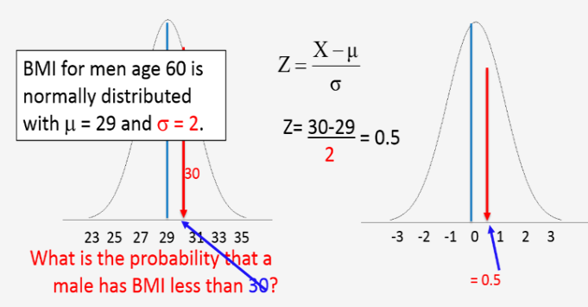
The best way to do this is to find the area below BMI=30, which we already know is 0.566, and the area above BMI=40, which we already know is 0.03338. The total area is 1, so we can add the area below 30 and the area above 40 and subtract the sum from 1 as follows:
P(30< X < 40) = 1 - (0.5662+ 0.03338) = 1-0.59958 = 0.40
Or we could do this using R:
> pnorm(30,29,6)-pnorm(40,29,6)
[1] -0.4004397

